**Student roll**

* Enrollemnt and payment
* Veiw result
* Veiw course

**Teachers roll**

* Course in side course add course
* View student rank
* Add exam
* 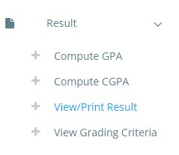
* 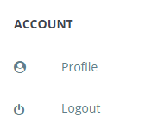

**Admin roll**

* Session in side this add session
* Veiw payment
* Veiw user
* View feedback